Azure Blobs

Azure Blob (Binary Large Object) storage provide you a platform where you can store and access unstructured data. Unstructured data is data that doesn't adhere to a particular data model or definition, such as text or binary data.

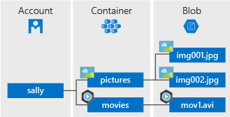

Where We Use:

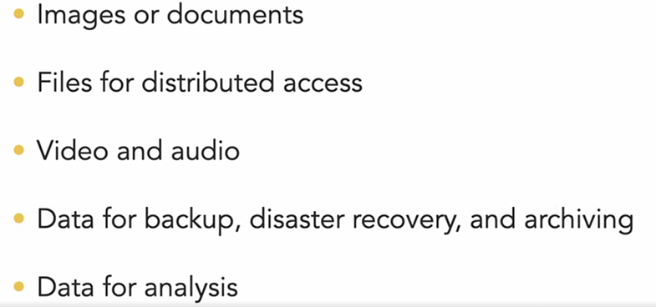

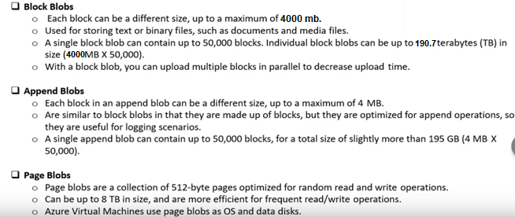

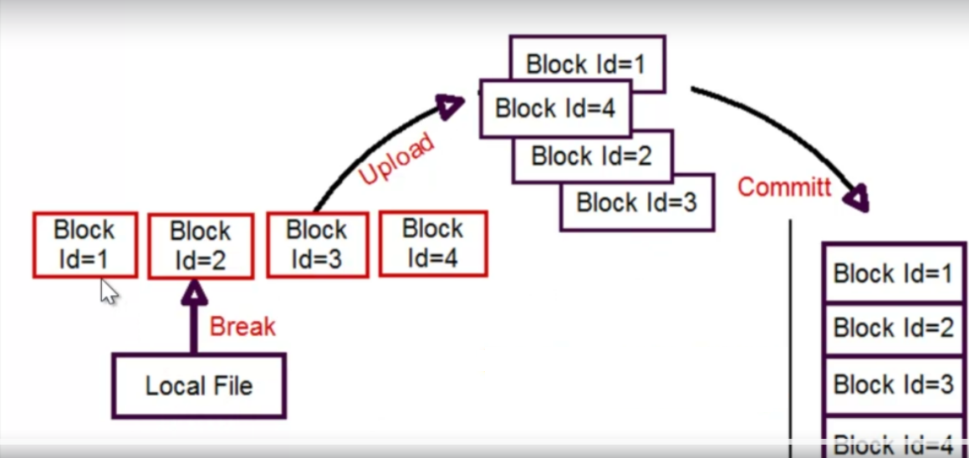

Append Blob is specifically optimized for operations where we need to keep adding data to a blob in chunks without modifying the already existing content. Every newly added data appends to the end of the blob, operation being referred as appending.

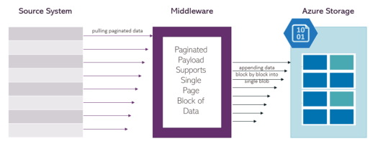

Page Blob are optimized for random access. A Page Blob is a collection of pages of 512 bytes and are useful when we need to support random access to the content (read and write).

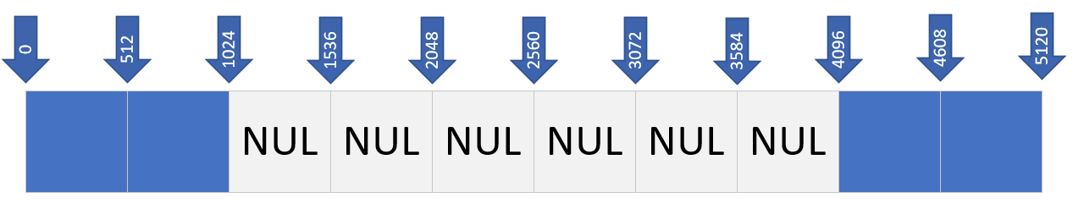

Comparison

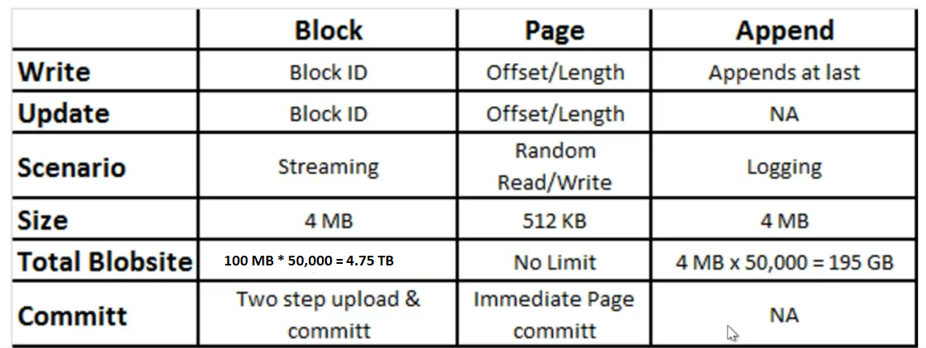

Access Tiers:

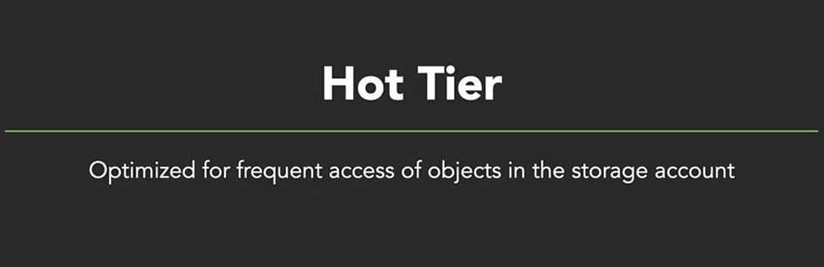

Pricing

